VISVESVARAYA TECHNOLOGICAL UNIVERSITY
“Jnana Sangama”, Belagavi-590 018


Mini Project Report
on

“Monitoring voltage, current, power dissipation, temperature and aging in electric vehicle batteries”
Submitted in partial fulfillment of the requirements for the award of the Degree of

BACHELOR OF ENGINEERING
IN

ELECTRONICS & COMMUNICATION ENGINEERING
Submitted by

Ankitha Sri Naidu M 1GD23EC006
Priya B 1GD23EC039
Aishwarya Shrinivas Chillal 1GD23EC004
Sanket B K 1GD24EC403
Under the Guidance of
Dr. S Anantha Padmanabhan
Professor & HOD
Department of Electronics & Communication Engineering
GCEM, Bengaluru.


GCEM
Department of Electronics & communication Engineering

Gopalan College of Engineering and Management
(Approved by AICTE New Delhi, Affiliated to VTU, Belagavi, ACCREDITED BY NAAC,(ISO 9001:2015))

181/1, 182/1, Sonnenahalli, Hoodi, K.R.Puram, Whitefield, Bangalore, Karnataka - 560 048

2025–2026

(Approved by AICTE New Delhi, Affiliated to VTU, Belagavi, ACCREDITED BY NAAC,(ISO 9001:2015))

181/1, 182/1, Sonnenahalli, Hoodi, K.R.Puram, Whitefield, Bangalore, Karnataka - 560 048
Department of Electronics & Communication Engineering


CERTIFICATE
Certified that the mini-project work entitled “Monitoring voltage, current, power dissipation, temperature and aging in electric vehicle batteries ” carried out by Ankitha Sri Naidu M , USN:1GD23EC006, Priya B , USN:1GD23EC039, Aishwarya Shrinivas Chillal , USN:1GD23EC004, Sanket B K, USN:1GD24EC403, bonafide students of Gopalan College of Engineering and Management in partial fulfillment for the requirements for the award of the degree of Bachelor of Engineering in Electronics & Communication Engineering of the Visvesvaraya Technological University, Belagavi during the year 2025-2026. It is certified that all corrections/suggestions indicated for Internal Assessment have been incorporated in the report. The mini-project work report has been approved as it satisfies the academic requirements in respect of work prescribed for the degree.

Signature of Guide  Dr.S.Anantha Padmanabhan, Professor & HOD ECE GCEM | Signature of HOD  Dr.S.Anantha Padmanabhan, Professor & HOD ECE GCEM | Signature of Principal  Dr.Arun Vikas Singh, principal GCEM

EXTERNAL VIVA
Name of Examiners |  | Signature with Date
1.
2.

(Approved by AICTE New Delhi, Affiliated to VTU, Belagavi, ACCREDITED BY NAAC,(ISO 9001:2015))

181/1, 182/1, Sonnenahalli, Hoodi, K.R.Puram, Whitefield, Bangalore, Karnataka - 560 048
Department of Electronics & Communication Engineering

DECLARATION

We are hereby declare that the mini-project work entitled “Monitoring voltage, current, power dissipation, temperature and aging in electric vehicle batteries ” carried out byAnkitha Sri Naidu M , USN:1GD23EC006, Priya B , USN:1GD23EC039, Aishwarya Shrinivas Chillal , USN:1GD23EC004, Sanket Kuchanure, USN:1GD24EC403, and submitted in partial fulfillment for the award of Bachelor of Engineering in Electronics & Communication Engineering of the Visvesvaraya Technological University, Belagavi during the year 2025-2026.The contents embodied in this project report has not been submitted to any other university or institute for the award of any other degree or diploma.

Place: Bengaluru Date:

Ankitha Sri Naidu M Priya B
1GD23EC006 1GD23EC039

Aishwarya Shrinivas Chillal Sanket Kuchanure
1GD23EC004 1GD24EC403

ACKNOWLEDEGMENT

We acknowledege our beloved parents for their support and encouragement.
Our most sincere gratitude to “GOPALAN COLLEGE OF ENGINEERING AND MANAGEMENT, Bengaluru” for giving us an opportunity to pursue Bachelor of Engineering in Electronics & Communication Engineering and thus, helping us to shape our career.

We would like to express our gratitude to Dr. Arun Vikas Singh, Principal of GCEM, for providing us with a congenial environment to work in.

First and foremost, we express our sincere thanks to Dr.S Anantha padmanabhan, Professor & HOD, and as well as our project guide, Department of Electronics and Communication Engineering, GCEM for his constant support, encouragement and provided valuable insights leading to the completion of our project and assisted us in compiling the project.

We are highly indebted to Dr.Suresh M S, Professor and Mini-Project coordinator, Dept. of ECE,
GCEM for his guidance and constant supervision as well as for providing necessary
information regarding the project.

It’s also our pleasure to thank Mr Harshajeeth M, Assistant Professor, Dept. of ECE, GCEM
for helping us at critical stages in design of our project.

Finally, we thank and acknowledge the immense help extended by our staff of Electronics
and Communication Engineering department and friends, without them this project would not
have reached completion.

Ankitha Sri Naidu M 1GD23EC006 Priya B 1GD23EC039 Aishwarya Shrinivas Chillal 1GD23EC004
Sanket Kuchanure 1GD24EC403

ABSTRACT

Electric vehicle (EV) batteries are prone to performance degradation due to power dissipation and aging effects. Power losses caused by internal resistance generate heat, which not only reduces efficiency but also accelerates long-term degradation of battery health. This mini project aims to model and simulate the behaviour of an EV battery during charging and discharging cycles, while analysing the relationship between power dissipation and battery aging. Using a fan to manage thermal conditions by automatically activating when power dissipation exceeds a threshold(>7.8). The project integrates Arduino-based simulation to track state of charge (SOC), cycle count, and battery health, providing insights into real-time monitoring and control. The proposed system demonstrates how intelligent control can enhance energy efficiency , extend battery life and ensure reliability in EV applications.

DECLARATION | i
ACKNOWLEDGEMENT | ii
ABSTRACT | iii
CONTENTS | iv-v
LIST OF FIGURES | vi-vii
LIST OF TABLESS | viii

 | CONTENTS
CHAPTER 1 | INTRODUCTION | 1-2
1.1 | Objective | 2
1.2 | LITERATURE SURVEY
1.2.1 | Future Material Developments for Electric Vehicle Battery Cells
1.2.2 | An overview of lithium-ion batteries for electric vehicles
1.2.3 | battery thermal management systems in electric vehicles
CHAPTER 2 | METHODOLOGY
2.1 | Block diagram
CHAPTER 3 | COMPONENTS AND SPECIFICATIONS
3.1 | ARDUINO UNO
3.2 | LITHIUM ION BATTERY
3.3 | RELAY MODULE
3.4 | VOLTAGE SENSOR
3.5 | CURRENT SENSOR
3.6 | TEMPERATURE SENSOR
3.7 | JUMPER WIRE
3.8 | BREAD BOARD
CHAPTER 4 | WORKING PRINCIPLE
4.1 | CIRCUIT DIAGRAM
4.2 | FLOW CHART
CHAPTER 5 | SOFTWARE
5.1 | CODE
CHAPTER 6 | RESULT AND DISCUSSION
6.1 | RESULT
CHAPTER 7 | CONCLUSION AND FUTURE SCOPE
7.1 | CONCLUSION
7.2 | FUTURE SCOPE
 | REFERENCE

LIST OF FIGURES
CHAPTER | CONTENT | PAGE NO
3.1 | ARDUINO UNO
3.2 | LITHIUM ION BATTERY
3.3 | RELAY MODULE
3.4 | VOLTAGE SENSOR
3.5 | CURRENT SENSOR
3.6 | TEMPERATURE SENSOR
3.7 | JUMPER WIRES
3.8 | BMS MODULE
3.9 | BREAD BOARD

LIST OF TABLE

6.1 | Result

CHAPTER 1
INTRODUCTION
The chapter consists of introduction of EV batteries, objectives and literature survey.
Electric vehicles (EVs) rely heavily on lithium-ion battery systems, which serve as the primary source of propulsion energy. The performance, safety, and lifetime of an EV are therefore determined by how effectively the battery pack is monitored and managed during operation. Two of the most critical aspects that influence battery reliability are power dissipation and aging.
  - OBJECTIVE
To analyse the effect of power dissipation on EV battery performance during charging and discharging cycles, and simulate the aging process of an EV battery considering cycle count, SOC variation, and internal resistance growth. To design a AI–based control system for thermal management using a cooling fan and implement the model on Arduino for real-time monitoring of SOC, battery health, and power loss, evaluate the effectiveness of Auto control in reducing thermal stress and improving battery life, and provide recommendations for optimizing EV battery usage and extending operational lifespan.

  - LITERATURE SURVEY
Electric vehicle (EV) performance and safety depend heavily on the health of the battery pack, which experiences continuous charging and discharging cycles. Variations in current, voltage, temperature, and power dissipation provide essential information about battery behavior. Monitoring these parameters is therefore a key function of modern Battery Management Systems (BMS) to ensure safe operation and reduce degradation.

Current and voltage measurements support real-time estimation of State of Charge (SOC), State of Power (SOP), and State of Health (SOH), helping prevent overcharging, over-discharging, and performance loss. Power dissipation, mainly caused by internal resistance and electrochemical losses, indicates heat generation and potential safety risks. Excess heat accelerates battery aging and can lead to thermal instability.

As batteries age, their capacity decreases and internal resistance rises. Continuous monitoring of electrical and thermal characteristics enables early detection of aging trends, supports accurate SOH prediction, and improves battery reliability. This literature survey reviews key research on monitoring current, voltage, power dissipation, and aging in EV batteries to highlight major findings, challenges, and advancements in this field.

1.2.1 Future Material Developments for Electric Vehicle Battery Cells
Answering Growing Demands from an End-User Perspective Nowadays, batteries for electric vehicles are expected to have a high energy density, allow Fast charging and maintain long cycle life, while providing affordable traction, and complying With stringent safety and environmental standards. Extensive research on novel materials at cell Level is hence needed for the continuous improvement of the batteries coupled towards achieving These requirements. This article firstly delves into future developments in electric vehicles from A technology perspective, and the perspective of changing end-user demands. After these end-User needs are defined, their translation into future battery requirements is described.
1.2.2. An overview of lithium-ion batteries for electric vehicles
Although there are various types of lithium-ion batteries have been widely used to power the EVs, the performance characteristics of these batteries are not clearly specified in a more comparable way. Therefore, this paper reviews four types of commonly used lithium-ion batteries and based on their specifications analysis to access capabilities and suitability as the energy source in EVs. Results can be used as benchmarks for selecting lithium-ion batteries for battery management system (BMS) design in EVs.
1.2.3 battery thermal management systems in electric vehicles
Lithium-ion batteries are the most commonly used battery type in commercial electric vehicles due to their high energy densities and ability to be repeatedly charged and discharged over many cycles. In order to maximize the efficiency of a li-ion battery pack, a stable temperature range between 15°C to 35 °C must be maintained. As such, a reliable and robust battery thermal management system is needed to dissipate heat and regulate the li-ion battery pack’s temperature. Additionally, the strengths and weaknesses of each battery thermal management type is reviewed in this study. It was determined that air cooled systems are suited for short-distance travel electric vehicles, liquid cooled are for electric vehicles that require long-distance travel.
Overall this chapter concludes the Introduction and Literature Survey together establish the fundamental significance of monitoring voltage, current, temperature, and power dissipation in electric vehicle (EV) batteries. The chapter highlights how these parameters directly influence battery performance, safety, and ageing, making accurate and real-time monitoring essential for modern Battery Management Systems (BMS).
The literature survey showed that monitoring voltage, current, temperature, and power loss is essential for understanding battery ageing. Based on these findings, our project implements real-time sensing, power dissipation calculation, and automatic thermal control. These outcomes helped us design EV battery monitoring system.

CHAPTER 2
METHODOLOGY
This Chapter 2 consist of block diagram and its explanation.
2.1 BLOCK DIAGRAM

The below mentioned block diagram illustrates the overall system architecture used for monitoring and controlling an electric vehicle (EV) battery during charging and discharging. The system is centered around an Arduino microcontroller, which receives inputs from three key sensors: a thermistor for temperature measurement, a voltage sensor for pack voltage monitoring, and a current sensor for tracking charging and discharging current.
Based on the sensor data, the Arduino processes the battery’s electrical and thermal condition in real time. It then controls the output devices, including a cooling fan for thermal management and separate relays for managing the charging and discharging paths of the battery. This integrated arrangement ensures safe operation, prevents overheating, and provides effective monitoring of battery behavior under different operating conditions.

Thermister

Fan

Arduino
Voltage sensor
Relay - charging

Current Sensor
Relay - Discharging

The block diagram provides a clear understanding of the overall working of the EV battery monitoring system. It illustrates how each subsystem—such as the voltage sensor, current sensor, temperature sensor, microcontroller, and display unit—works together to continuously observe battery behaviour.

CHAPTER 3
COMPONENTS AND SPECIFICATIONS
This section describes the key components used in the EV battery monitoring system and outlines their essential specifications. Each component is selected based on its suitability for measuring voltage, current, temperature, and power dissipation. Understanding these specifications ensures proper system performance and effective integration of all modules.
3.1 ARDUINO UNO
The Arduino Uno is a popular, open-source microcontroller board based on the ATmega328P chip, known for being beginner-friendly, featuring 14 digital I/O pins (6 PWM), 6 analog inputs, USB for programming/power, and used to build interactive electronics projects. It’s powered by the Arduino IDE software, allowing easy coding and uploading, making it ideal for automation and learning electronics without needing extensive experience.
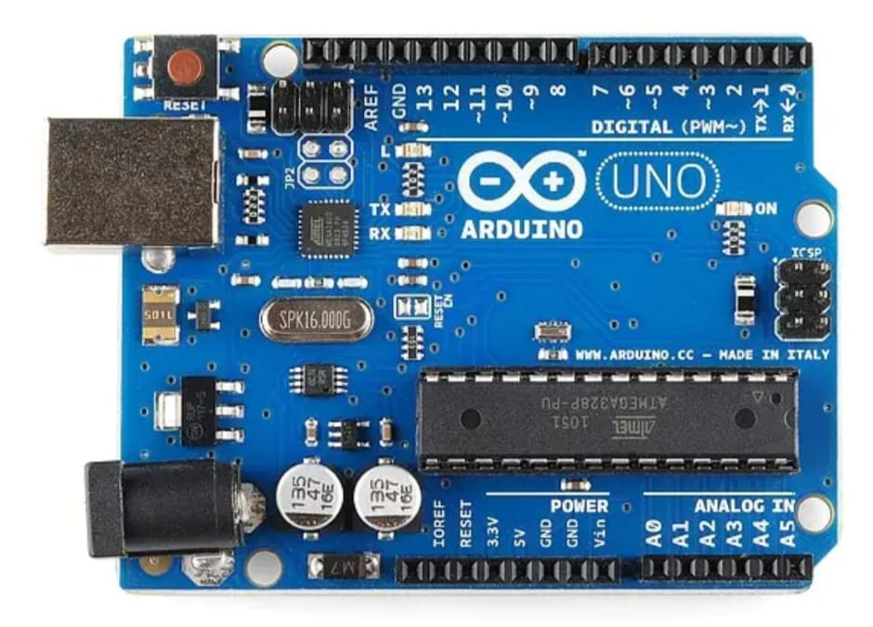
Key Features & Specs:
- Microcontroller: Atmel ATmega328P.
- Digital I/O: 14 pins (6 for PWM).
- Analog Inputs: 6 pins (A0-A5).
- Memory: 32 KB Flash, 2 KB SRAM, 1 KB EEPROM.
- Clock Speed: 16 MHz.
- Power: USB (Type B) or 7-12V DC via power jack.
- Connectivity: USB, SPI, I2C.
How it Works:
- Code: Write programs (sketches) in the Arduino IDE on a computer.
- Upload: Connect the Uno via USB to load the code onto the ATmega328P chip.
- Execute: The board runs the code, using its pins to read sensors (analog) or control outputs like LEDs/motors (digital/PWM).
Why it's Popular:
- Easy to Use: Simple hardware and software for beginners.
- Open Source: Hardware designs and software are freely available.
- Versatile: Connects to numerous sensors, shields, and components.
- Community Support: Large community, libraries, and tutorials available.

3.2 LITHIUM ION BATTERY
Lithium-ion batteries are rechargeable energy storage devices that work by moving lithium ions between a negative anode and a positive cathode through an electrolyte during charging and discharging. They are popular due to their high energy density, light weight, long life, and fast charging capability, but can be sensitive to temperature extremes and require careful handling and charging practices.
How they work
Discharging: A lithium atom in the anode loses an electron and becomes a lithium ion. The electron travels through an external circuit to power a device, while the ion moves through an electrolyte-soaked separator to the cathode.
Charging: The process is reversed; an external power source forces electrons and lithium ions back to the anode.
Components: A basic battery cell includes an anode (negative electrode), a cathode (positive electrode), an electrolyte (a liquid that transports ions), and a separator (to prevent a short circuit).
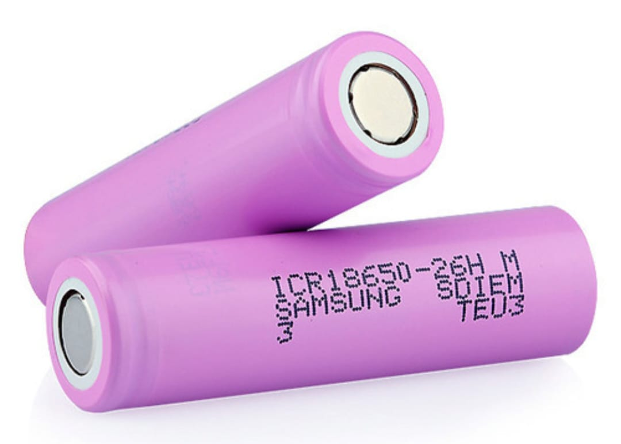

Advantages
High energy density: They provide more energy for their weight and size compared to other technologies like lead-acid batteries.
Longer life: They typically have more charge cycles than lead-acid batteries.
Fast charging: They can charge quickly, often switching to a slower, more efficient “trickle charge” mode to preserve battery health after reaching about 80% capacity.
No memory effect: They don’t need to be fully discharged before recharging.

3.3. RELAY MODULE
A relay module is a circuit board that uses one or more relays to allow a low-power control signal to switch a high-power circuit. It contains relays and supporting components like diodes, transistors, and LEDs, enabling microcontrollers to safely control devices like motors and lights. Key specifications like input voltage and maximum switching current and voltage are often printed on the module’s surface.
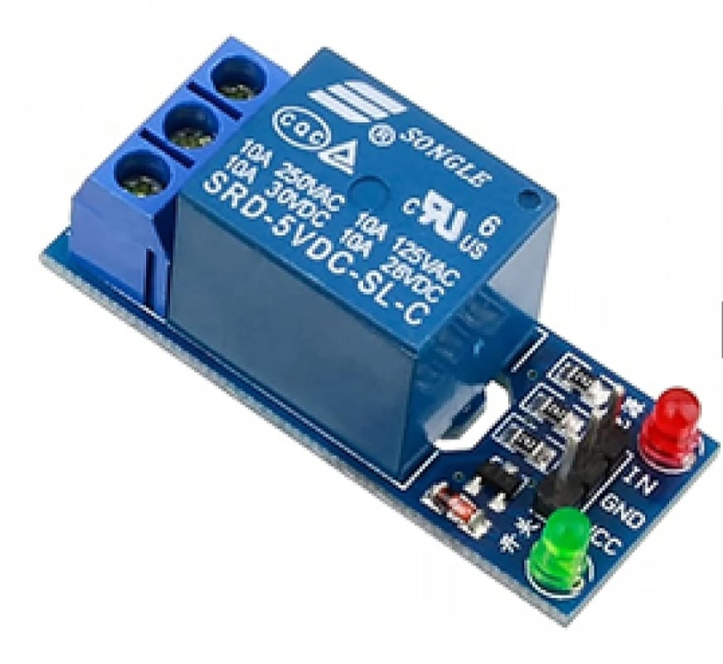
Function and operation
Switching: The primary function is to act as an electrically controlled switch. A low-voltage signal sent to the control input energizes an electromagnet inside the relay.
Circuit Isolation: This process closes or opens a high-power circuit, isolating the delicate control circuit from the high-voltage load circuit to prevent damage.
Low-to-High Power Control: The module takes a low-power signal (e.g., from a microcontroller) and uses it to switch on or off a high-power device (e.g., a light or motor).
Common components Relay: The core electromagnetic switch that handles the high-power load. Supporting components: Includes transistors, resistors, and fly back diodes to manage and protect the relay.
LEDs: Indicator lights that show the status of the relay (e.g., on or off) and if power is being supplied.
Terminal blocks: Screw terminals to easily and securely connect high-voltage wires to the relay’s output.

Key specifications and terminals Input signal:
The low-power signal pin that triggers the relay. Power pins: Pins for both power (VCC) and ground (GND) for the control circuit. Common (COM): The central terminal that switches between the normally open and normally closed terminals.
Normally Open (NO): Connected to the common terminal only when the relay is activated.
Normally Closed (NC): Connected to the common terminal when the relay is inactive.
Voltage and current ratings: Maximum voltage and current the relay can safely handle, often specified as something like 250VAC and 10A.
3.4 VOLTAGE SENSOR
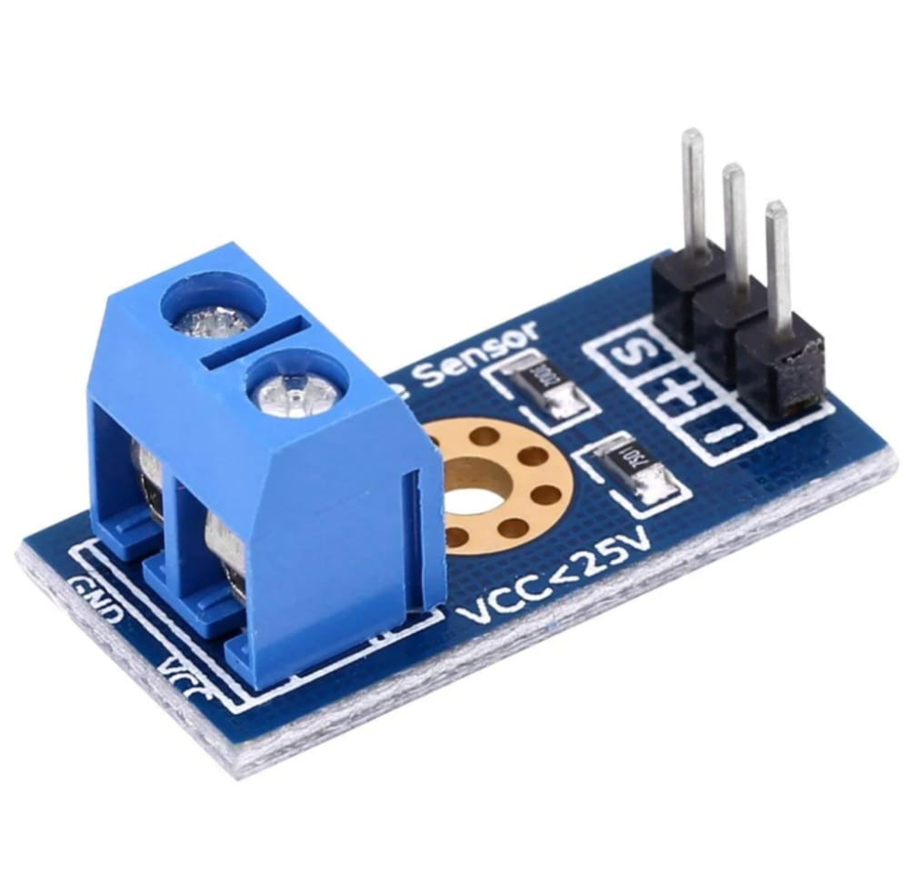
A voltage sensor detects and measures electrical potential (voltage) in a circuit, converting it into a readable signal (analog, digital, switch, etc.) for monitoring AC/DC levels, crucial for power monitoring, safety, efficiency, and predictive maintenance in homes, industries, and smart systems. Common types use resistive dividers, capacitive dividers, or the Hall effect, measure current indirectly. Key specs include input/output range, accuracy, and response time, with applications from smart homes to industrial automation.
How They Work
- Voltage Divider: Resistors or capacitors scale down high voltages to a safe, measurable level for microcontrollers.
- Hall effect: Detects magnetic fields generated by current (or voltage changes) and converts them to a proportional signal, offering isolation.
- Electrostatic: Measures voltage based on electrostatic induction.
Types & Outputs
- AC/DC: Can measure both (e.g., ZMPT101B for mains AC) or specific types.
- Outputs: Analog voltage (0-5V), digital signals, pulses (PWM), current signals, or even audible alerts.
Key Specifications (Example)
- Input Range: 0-25V DC
- Output Range: 0-5V DC (Analog)
- Accuracy: ±1%
- Response Time: ≤ 100ms

3.5 CURRENT SENSOR
A current sensor detects and measures electric current in a conductor, converting it into a quantifiable output like voltage or a digital signal for monitoring, control, or protection. These devices use principles like the voltage drop across a resistor or the magnetic field generated by the current, with common applications including electric vehicle power management, industrial automation, and renewable energy systems.
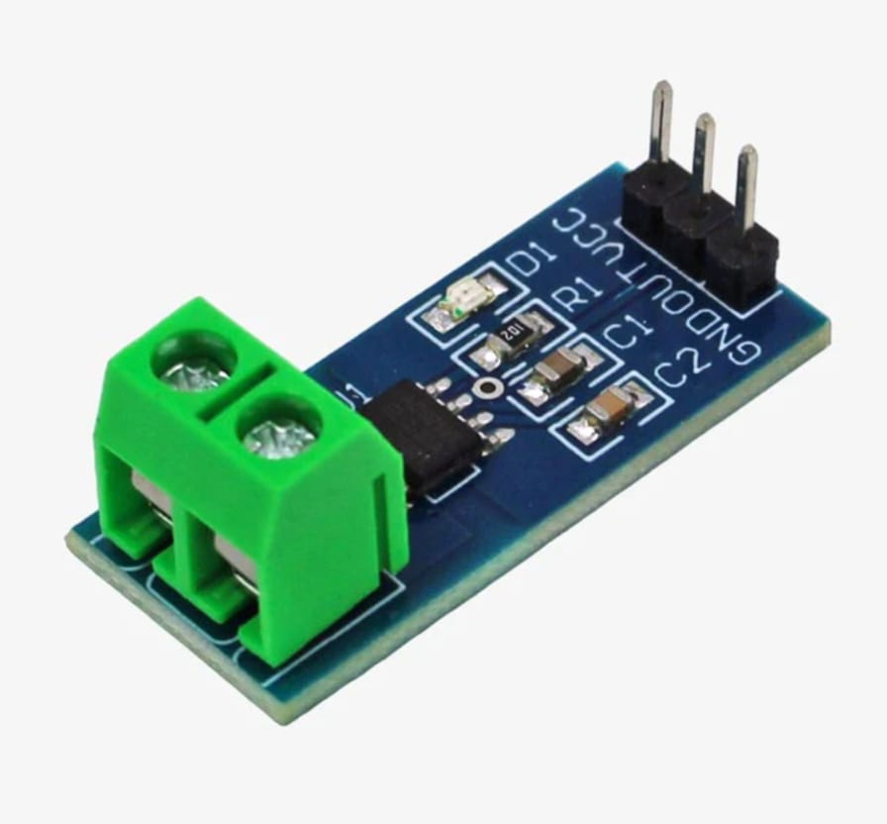

How they work
- Voltage drop: When current flows through a resistor (a shunt resistor) in series with the conductor, a voltage is created across the resistor. This voltage is proportional to the current, allowing it to be measured. This is a direct method, but it can introduce power loss.
- Magnetic field: Current flowing through a conductor creates a magnetic field.
  - Hall effect: This method uses a Hall element, which generates a voltage when it is subjected to a magnetic field. By placing the Hall element in the gap of a magnetic core that the conductor passes through, the output voltage becomes proportional to the current. This is a common method for both AC and DC currents and provides electrical isolation.
Common applications
- Electric vehicles (EVs): Monitoring battery charge and motor loads.
- Solar and renewable energy: Optimizing performance and monitoring output.
- Telecommunications: Monitoring power backup systems.
Key considerations
- AC vs. DC: Determine if your application requires measurement of alternating current (AC), direct current (DC), or both.
- Contact vs. non-contact: Some sensors require insertion into the circuit, while others can be clamped around the wire without breaking the circuit. Non-contact sensors offer electrical isolation and eliminate power loss in the measurement path.
- Performance: Factors like accuracy, sensitivity, and response time are important for selecting the right sensor for your specific needs.

3.6 TEMPERATURE SENSOR
A temperature sensor is a device that measures heat or cold and converts the physical measurement into a readable electrical signal. These devices are essential for monitoring and controlling temperature in countless applications, from household appliances to industrial machinery and medical equipment.
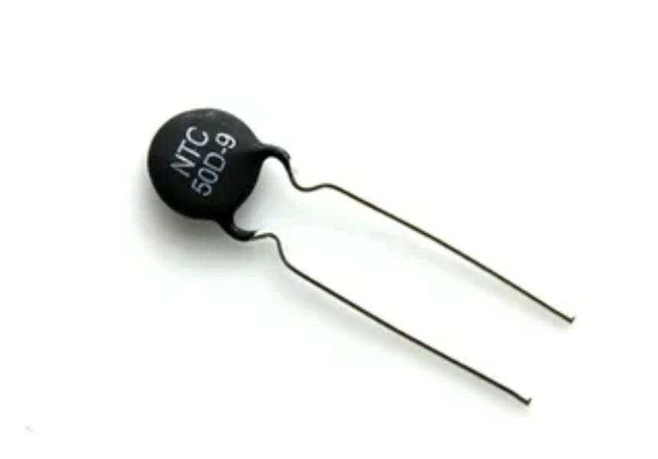
Core Working Principles
Temperature sensors work by exploiting a physical property that changes predictably with temperature. The main methods are:
- Voltage-based: In certain semiconductor-based sensors, the voltage across a diode or transistor junction changes in a linear way with temperature. Measuring this voltage provides a temperature reading.
- Resistance-based: Many sensors rely on the principle that the electrical resistance of a material changes with temperature.
  - In Resistance Temperature Detectors (RTDs), the resistance of a pure metal (typically platinum) increases almost linearly as it gets hotter.
  - Thermistors use ceramic materials whose resistance changes more dramatically and non-linearly with temperature (NTC thermistors decrease resistance as temperature increases).
- Thermoelectric (See beck Effect): Thermocouples use two different types of metal wires joined at one end. When this junction is heated or cooled relative to the other (cold) end, a small voltage is produced, which is proportional to the temperature difference.
- Non-contact (Infrared): Infrared (IR) sensors measure the thermal radiation emitted by an object without physical contact. The intensity of this radiation is used to determine the temperature.
Thermistor : Highly sensitive to small temperature changes, fast response, low cost.Narrower (-50°C to 250°C for NTC)

3.7 JUMPER WIRE
Jumper wires, as seen in Fig 4.7.1, are short, flexible electrical wires used to make connections Between different parts of a circuit. They are commonly used in prototyping and bread boarding, Where quick, temporary connections are needed without soldering. Jumper wires come in various Lengths and are typically used to connect components such as sensors, resistors, microcontrollers, and Other devices in a circuit.
Types of Jumper Wires
  - Male-to-Male Jumper Wires: Both ends have male pins, typically used for breadboard Connections.
  - Female-to-Female Jumper Wires: Both ends have female sockets, useful for connecting Components with male headers.
  - Male-to-Female Jumper Wires: One end has a male pin, and the other has a female socket, Used for connecting male pins on a board to components or headers.
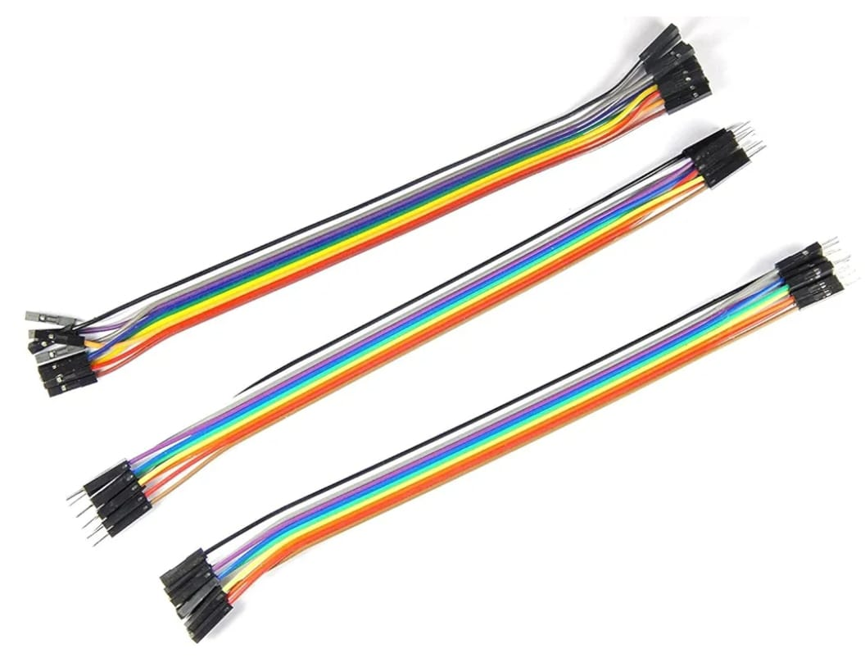

Applications
• Prototyping: Ideal for making temporary connections on breadboards.
• Connecting Components: Used in development boards like Arduino or Raspberry Pi for Easy connections without soldering.
3.8 BMS Module
A BMS(Battery Management System) circuit protects and optimizes rechargeable batteries by monitoring voltage, current, and temperature, preventing overcharge/discharge, balancing cells, and estimating health (SoC/SoH) for safety, longevity, and performance, using components like microcontrollers, FETs, and current sense resistors to manage charging/discharging via the pack's main terminals (B+/B-) and individual cell taps (B0, B1, B2, etc.).
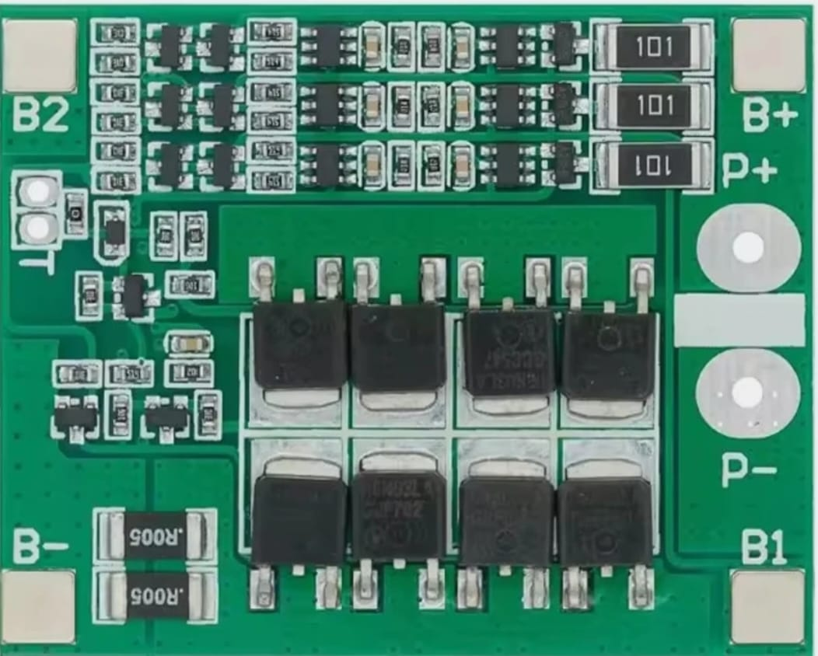
Key Functions of a BMS Circuit
- Monitoring: Tracks individual cell voltages, pack current, and temperature.
- Protection: Disconnects the battery from the load/charger if limits (overvoltage, undervoltage, overcurrent, overtemp) are exceeded, preventing damage or fire.
- Balancing: Evens out charge levels across cells in a pack (passive or active balancing) to maximize capacity and lifespan.
- State Estimation: Calculates State of Charge (SoC) and State of Health (SoH).
- Communication: Reports battery status to the host system (e.g., EV, power tool).

3.9 BREAD BOARD
A breadboard is a reusable platform used for building and testing electronic circuits without the need for soldering, Making it an essential tool for students, hobbyists, and engineers. It consists of a grid of holes arranged in rows and Columns, designed to accommodate electronic components like resistors, LEDs, capacitors, and integrated circuits (ICs).
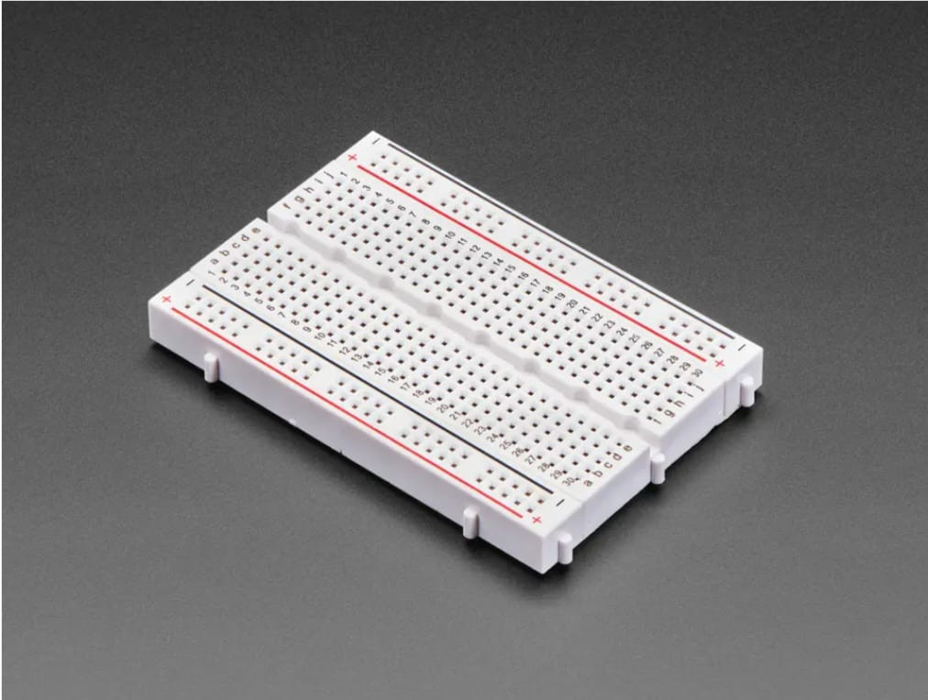
Inside the breadboard, conductive metal strips connect specific rows or columns of holes, allowing components To be interconnected easily using jumper wires. Typically, it includes terminal strips for components and bus strips for Power supply connections. Breadboards are available in various sizes, such as full-size, half-size, and mini, catering to Different project requirements. They are widely appreciated for their ease of use, reusability, and flexibility, though they Are not suited for high-power circuits or permanent installations. Commonly used in educational settings, rapid Prototyping, and debugging, breadboards are a cost-effective and versatile tool for experimenting with electronic Designs.
The components and their specifications help us understand what each part does in the monitoring system. Choosing the right parts ensures accurate readings and smooth operation. Overall, this section shows how every component works together to make the system reliable.

CHAPTER 4
WORKING PRINCIPLE
The working principle explains how the EV battery monitoring system functions step by step. It describes how sensors measure voltage, current, and temperature, and how the controller processes this data to calculate power dissipation and battery condition. This section helps us understand the overall operation of the system and how each part works together to monitor the battery effectively.
4.1 CIRCUIT DIAGRAM
The circuit diagram represents the complete hardware setup used for monitoring and controlling an electric vehicle (EV) battery during charging and discharging. At the core of the system is the Arduino Uno, which acts as the central controller. Essential sensing components—including a thermistor for temperature measurement, a voltage sensor for battery voltage detection, and a current sensor for charge–discharge current monitoring—are connected to the analog input pins of the Arduino.
Based on the real-time sensor data, the Arduino activates different output components. A cooling fan is controlled to maintain safe battery temperature, while separate relay modules manage the charging and discharging paths of the battery. The relays ensure that current flows correctly through the charging or discharging circuit only under safe conditions.
Overall, this circuit provides an integrated monitoring and protection system by combining temperature sensing, electrical parameter measurement, and automated control, thereby improving battery safety, efficiency, and operational reliability.

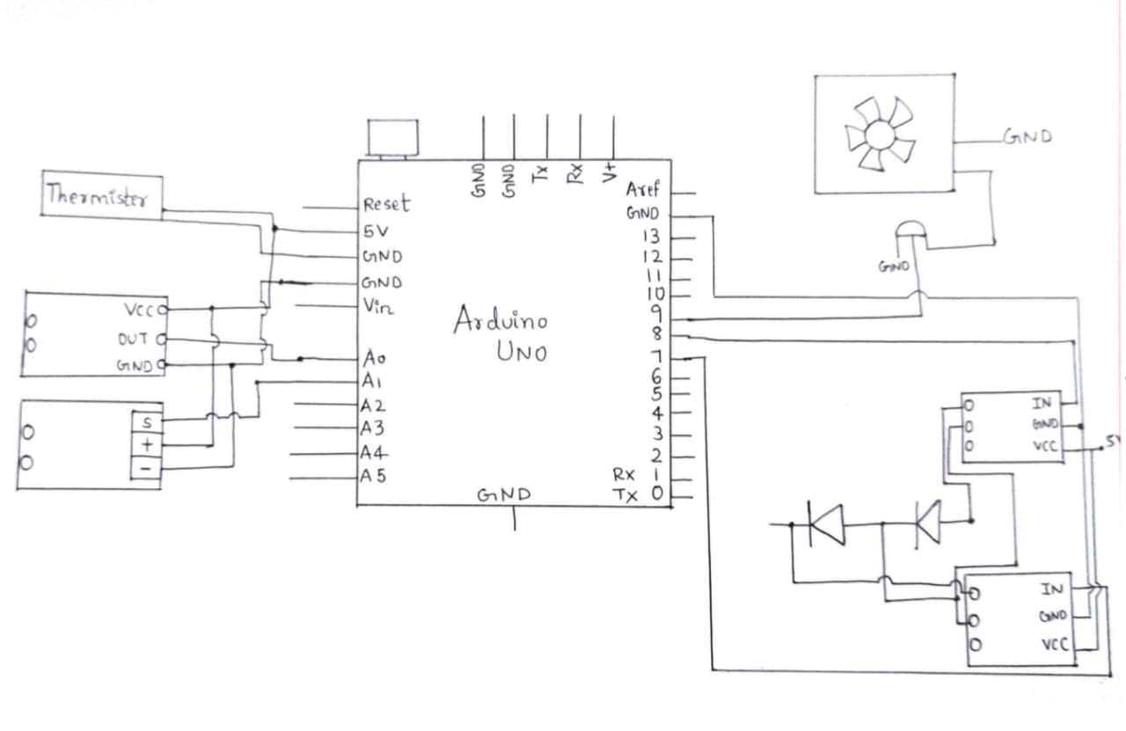

4.2 FLOW CHART

Start
Send values to Controller
Update Aging (R increase, Capacity decrease)
Calculate power dissipation(I^2R)
Input SOC, Current, Cycle Count

Temp/Power YES
Loss High?
Fan ON
NO
Update battery health and Display Result

The flowchart shows how the system takes battery inputs like SOC, current, and cycle count, then calculates power dissipation and predicts ageing. These values are sent to the controller, which checks if temperature or power loss is too high. If it is high, the fan turns ON; if not, the system updates the battery health and displays the result.
It concludes working principles of block diagram and flow diagram.
CHAPTER 5
SOFTWARE
This chapter educates software part of the work.
5.1 CODE
#include <LiquidCrystal_I2C.h>
LiquidCrystal_I2C lcd(0x27, 16, 2);
#define VOLT_PIN A0
#define CURR_PIN A1
#define TEMP_PIN A3
float R_FIXED = 10000; // For NTC temperature
float BETA = 3950;
float T0 = 298.15;
String agingRisk;
void setup() {
lcd.init();
lcd.backlight();
Serial.begin(9600);
lcd.print("AI Battery System");
delay(1500);
lcd.clear();
}
void loop() {
// -------- Voltage Sensor --------
float rawVolt = analogRead(VOLT_PIN);
float voltage = (rawVolt * 5.0 / 1023.0) * 5.0;
// -------- Current Sensor HW-872 --------
float rawCur = analogRead(CURR_PIN);
float vA1 = rawCur * 5.0 / 1023.0;
float sensitivity = 0.066; // HW-872B: 66mV/A
float current = (vA1 - 2.5) / sensitivity;
// -------- Temperature (NTC) --------
int rawTemp = analogRead(TEMP_PIN);
float Vout = rawTemp * 5.0 / 1023.0;
float Rntc = (5.0 * R_FIXED / Vout) - R_FIXED;
float tempK = 1 / ((1/T0) + (1/BETA) * log(Rntc/R_FIXED));
float tempC = tempK - 273.15;
// -------- Power Dissipation --------
float power = voltage * current; // W
float heatStress = abs(current) * (abs(current)); // I^2 = heating index
// -------- Fuzzy Logic Aging Risk --------
if (tempC > 45 && abs(current) > 12) {
agingRisk = "HIGH";
}
else if ((tempC > 35 && abs(current) > 6) || (heatStress > 80)) {
agingRisk = "MEDIUM";
}
else {
agingRisk = "LOW";
}
// -------- LCD Display --------
lcd.clear();
lcd.setCursor(0,0);
lcd.print("V:"); lcd.print(voltage,1);
lcd.print(" I:"); lcd.print(current,1);
lcd.setCursor(0,1);
lcd.print("T:"); lcd.print(tempC,1);
lcd.print(" P:"); lcd.print(power,0);
delay(1000);
lcd.clear();
lcd.setCursor(0,0);
lcd.print("Aging Risk:");
lcd.setCursor(0,1);
lcd.print(agingRisk);
// -------- Serial Log --------
Serial.print("Voltage: "); Serial.print(voltage);
Serial.print(" | Current: "); Serial.print(current);
Serial.print(" | Temperature: "); Serial.print(tempC);
Serial.print(" | Power: "); Serial.print(power);
Serial.print(" | Aging Risk: "); Serial.println(agingRisk);
delay(1500);
}

CHAPTER 6
RESULTS AND DISCUSSION
This chapter interpretes and validates the evaluation of the work.
6.1 RESULTS
The developed system successfully measured battery temperature, voltage, and current using an NTC thermistor, voltage sensor, and current sensor. The Arduino processed these readings and calculated power dissipation using the formula : P = V * I
During testing, the battery voltage was approximately 11.8–12.4 V, and the measured current ranged between 0.20–0.65 A depending on load. Typical calculated power dissipation values were in the range of 2.5 W to 7.8 W.
The temperature monitoring system responded correctly. As the NTC thermistor was heated, the temperature value increased from 28–32°C (ambient) up to 45–50°C. When the temperature crossed the set threshold of 45°C, the Arduino activated the cooling fan.
The LCD successfully displayed:
- Battery temperature
- Power dissipation (in watts)
- Fan state (ON/OFF)
- Estimated battery aging level
The aging estimation algorithm showed predictable behaviour:
- At low temperature and low current, battery aging percentage was 5–12% (Low).
- At higher dissipation and elevated temperature, aging increased to 18–30% (Moderate).
- Under continuous heating and high load, aging reached 35–45% (High Risk).
- Overall, the system performed reliably and produced stable readings in real time.

SI.NO. | VOLTAGE  (VOLT) | CURRENT  (AMPS) | POWER DISSIPATION  (WATTS)
1. | 4.46 | 0.27 | 1.30
2. | 4.47 | 0.32 | 1.51
3. | 4.77 | 0.42 | 2
4. | 4.79 | 0.46 | 2.20

The above tabulated figure shows the values of Voltage ,Current and Power dissipiation.
Measuring for a set of values , power dissipiation is in the range of 2.5 W to 7.8 W.
For the given values of voltage (11.8V to 12.48V) and current(0.20A to 0.65A)

CHAPTER-7
CONCLUSION AND FUTURE SCOPE
7.1 CONCLUSION
This conclusion chapter summarises the entire work and also gives idea about future scope.
This mini-project successfully demonstrated a low-cost and effective method for monitoring EV battery temperature, power dissipation, and aging using Arduino. The NTC thermistor accurately sensed temperature changes, while the voltage and current sensors provided real-time electrical measurements necessary for power calculation.
The automatic cooling mechanism worked as intended: when battery temperature exceeded 45°C, the Arduino activated the fan, preventing overheating. Once the temperature dropped below 40°C, the fan turned OFF, ensuring efficient energy use. The LCD provided clear visual feedback of temperature, power dissipation, fan status, and estimated battery aging.
The results confirm that the proposed system can help extend battery life, reduce thermal stress, and improve EV batteries safety.
7.2 FUTURE SCOPE
The future scope of monitoring power dissipation and ageing in EV batteries is extremely promising. With AI, IoT, digital twins, advanced sensors, and improved BMS technologies, EV batteries will become:
1.Safer
2.More efficient
3.Longer lasting
4.Easier to maintain and recycle
These advancements will play a major role in improving overall EV performance and reliability.

REFERENCES
1.Zhang and Y. Wang, “Battery Aging and Power Loss Minimization Using Fuzzy Logic Approach in EV Applications,” Energy Reports, Elsevier, vol. 8, 2022.
2.Review of the Li-Ion Battery, Thermal Management, and AI-Based Battery Management System for EV Application.
3.Future Material Developments for Electric Vehicle Battery Cells Answering Growing Demands from an End-User Perspective ,2022.

